**ERD Model PART 3**

Illustrate that you understand normalization and how to use it to reduce uncontrolled redundancy in your database design by creating two ERD diagrams:

**Answer:**  In this reformation of the ERD diagram we find that redundancy from a connection or gathering of relations is limited through the course of normalization. Insertion, deletion, and update abnormalities could result from social overt repetitiveness. In this manner, it assists with lessening social overt redundancy. Redundancy in data set tables is eliminated or diminished utilizing typical structures.

By analyzing new information types used in the table, standardization assists with taking out intricacy and overt repetitiveness. The enormous data set table can be separated into more modest tables and associated through connections. It holds a table back from having copy information or rehashing gatherings

Create the first using UML and the Umlet free utility.

**Answer:**

.  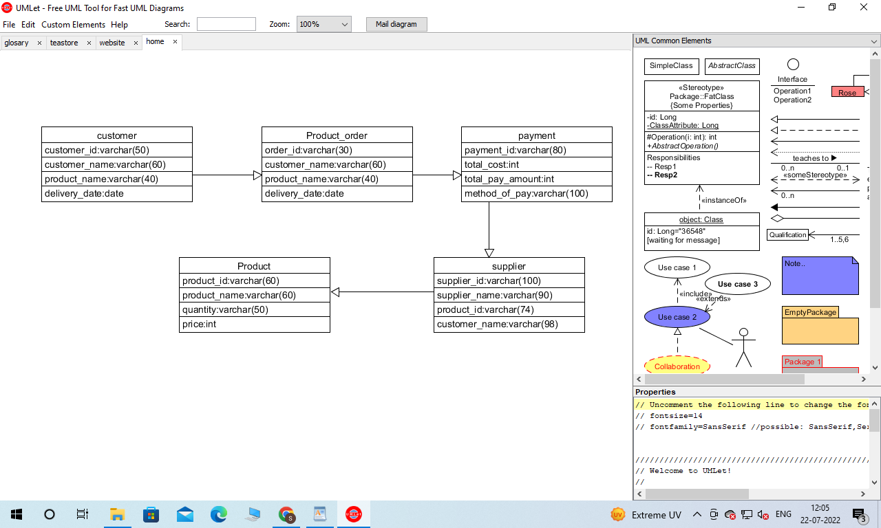

Create the second using Crow’s Foot notation in Vertabelo.

**Answer: Crow f**

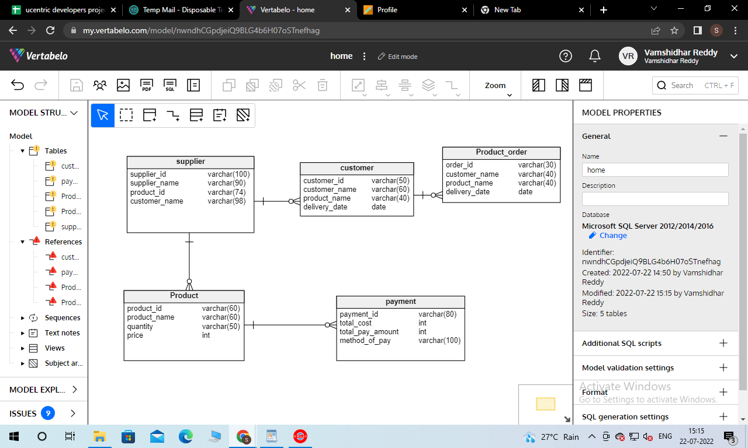

Upload both drawings to **GitHub**. The ERDs must both be **physical** models (includes data types and key information).

10 points for each physical model in GitHub for a total of 20 points.

See the help files in Blackboard, Week 3 for help using Umlet and Vertabelo.